**11011 FROM BASE 2 TO 10:**

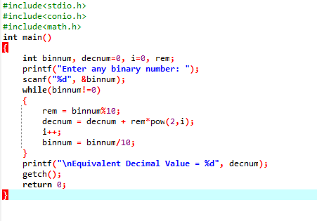

**OUTPUT:**

https://github.com/madhumithaniraimozhi/CSA5743-FOC-PRACTICALS-.git